**RMD ENGINEERING COLLEGE**

**An Autonomous Institution**

**IoT Based Safety Gadget for Child Safety Monitoring & Notification**

**TEAM ID:PNT2022TMID15125**

**TEAM MEMBERS:**

**VEMULA SRIJA(Team leader)**

**YAMALA HIMASREE**

**PULIMI HEMALATHA**

**J.SHARMILA**

INTRODUCTION

Child safety is a challenging problem nowadays due to antisocial Elements in the society. The crime rate is day by day increasing. Schools and working places need high surveillance for ensuring the Safety among children. Smart Gadget major role for ensuring the Safety, where some mobile based applications provide alert systems. During the emergency, Application alert the control room of nearby Police station or caretakers of children. The literature shows that Location tracking devices are available in the market, but it does not Provide the complete solution to the problem. The solution to this problem is to design an IoT device, which senses the child’s location And environment and during emergency, it should send the alert to the Parents automatically.

PROJECT OVERVIEW

Child tracker helps the parents in continuously monitoring the Child’s location. They can simply leave their children in school or parks And create a geofence around the particular location. By continuously Checking the child’s location notifications will be generated if the child Crosses the geofence. Notifications will be sent according to the child’s Location to their parents or caretakers. The entire location data will be Stored in the database.

PURPOSE

IoT Based Safety Gadget for Child Safety Monitoring & Notification Plays a key role in providing better care for the lost children until they Reconvene with the parents. In this present era, most of the wearable Devices today are designed based on the location, activity temperature, Pressure, etc of the child and in form the parents via GPS. Therefore it Is intended to use voice call as the way of communication between the Parent mobile and child’ s wearable device. The system operates on the Microcontroller board and the functions of sending and receiving Notifications ,calls, voice messages via GPS.

# IOT Based Safety Gadget for Child Safety Monitoring and Notification

* Now-a-days attacks on children are increasing at an unprecedented rate and the victims are in dangerous conditions, where they are not allowed to contact the family members.
* The key idea planned in this research work is an advanced technology that offers “Smart Child Safety” for the children.
* Therefore, the awareness of this method is to send an SMS from children’s wear tool to their parent or guardian.
* In the prevailing structure, there is no monitoring method for child, it should create many problems for them and the no protectionmechanism to protect the child from the misbehavior.
* In addition, there is no aware device for the child’s protection; it must be completed by hand only.
* Thus, the planned method will be highly effective when compared to the other existing techniques in helping the victims.
* Moreover, it doesn’t need any manual operation. This paper recommends a newfangled technology for child protection by using GSM so that the children will not feel abandoned while facing such social problems.
* The problems overawed here using Arduino UNO, GSM, sensors, MEMS, temperature and panic button by using IOT.
* In such case, Heartbeat Sensor track the best rate for children and sends the emergency message by using the GSM to save contacts.
* Such method is actually suppove for children in today’s world.
* Hence, this provides a security to the children and secures the feeling of parents.

# Keyword:

Arduino UNO; wearable device; IOT; GSM; GPS

# Advantages:

* Staying connected,
* Data accuracy ,
* Efficiency.

# Disadvantages:

* High cost but once it is implemented the expenses can be reduced.

# Intelligent Child Safety System using Machine Learning in IoT Devices

**Author :**

( Dr. Sreeja B S, Aparajith Srinivasan, Akshaya R, Abirami S,Divya N.)

* Child safety and tracking is of most importance as children are the most vulnerable.
* With increasing crime rates such as child kidnaping, child trafficking, child abuse and so on such as child kidnaping, child trafficking, child abuse and so on the need for an advanced smart security system has become a nnecessity
* With this motivation, a self-alerting“INTELLIGENT CHILD SAFETY SYSTEM USING MACHINE LEARNING IN IOT DEVICES” is developed to aid parents to monitor and track their children in real time as an alternate to stay beside them.
* This system is intended as an everyday wearable device on the child, in the form of a wrist band, hand glove, arm band or a belt.
* The system is designed to continuously monitor the location and body vitals of children.

This electronic system comprises of an Arduino controller, a Raspberry-Pi and sensors to detect the changes in parameters such as temperature, BVP (Blood Volume Pulse) and GSR (Galvanic Skin Response).

* The system also uses a GSM and GPS module. Decision Tree Classifier Algorithm is used to detect any distress situation with sensor values as inputs.
* The location of the victim is traced using the GPS module and is sent to the registered contact numbers as a text message using a GSM module.
* The work lies in the autonomous decision making process with increased accuracy.

# Keywords:

Child safety, GPS, GSM, Sensors, Arduino, Raspberry-Pi, Decision Tree

Classifier, Autonomous Decision, Intelligent Child Safety System using Machine Learning in IoT Devices.

# Advantage:

* According to the child mental and physical condition, when kids are in danger automatically the message notification will be sent to the parents (register number).
* Distance is not a barrier to track a child location - (GPS Tracker).

# Disadvantage:

* Decision Tree Classifier Algorithm is a complex structure.
* Cost is too high.

# IoT Based Safety Gadget for Child Safety Monitoring and Notification

**Authors:**

(H.M. Sabaa Fathima )

* This project discusses the concept of a smart wearable device for little children.
* The major pros of this wearable over other wearable is that it can be used in any cellphone and doesn't necessarily require an expensive smartphone and not a very tech savvy individual to operate.
* The purpose of this device is to help the parents to locate their child with ease.
* At the moment there are many wearables in the market which help track the daily activity of children and also help find the child using Wi-Fi and Bluetooth services present on the device.
* But Wi-Fi (Wireless Fidelity) and Bluetooth appear to be an unreliable medium of communication between the parent and child.
* Therefore, the focus of this project is to have an SMS text enabled communication medium between the child's wearable and the parent as theenvironment for GSM mobile communication.
* The parent can send a text as SMS with specific keywords such as “LOCATION”, “TEMPERATURE”, “SOS”, “BUZZ”, etc., to the wearable device.
* The device will replay backwith a text containing the real time accurate location of the child and will also provide the surrounding temperature, so that the parents can keep track if the temperature not suitable for the child.
* The secondary measure implemented was using a bright SOS Light and distress alarm buzzer present on the wearable device which can be activated by the parents via SMS text to display the SOS signal brightly and sound an alarm which a bystander can instantly react for the child's safety till the parents arrive or they could contact the parents and help locate them.
* Hence this project aims at providing parents with a sense of security for their child intoday's time.

# Keywords :

Children, Arduino, Safety, Wearable.

# Advantages:

* The ability to locate and track your child in real time is all made possible with IoT- enabled technology. They are many other benefits that IoT-enabled child tracks include; Keeps track of children in case of abduction.

# Disadvantages:

* The child could not produce the exact alert command during a panic condconditio
* The command

EMPATHY MAP CANVAS

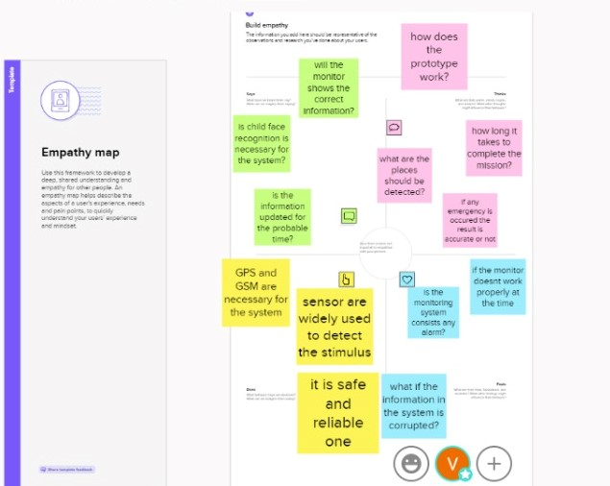

BRAIN STORM AND IDEA PRIORITIZATION

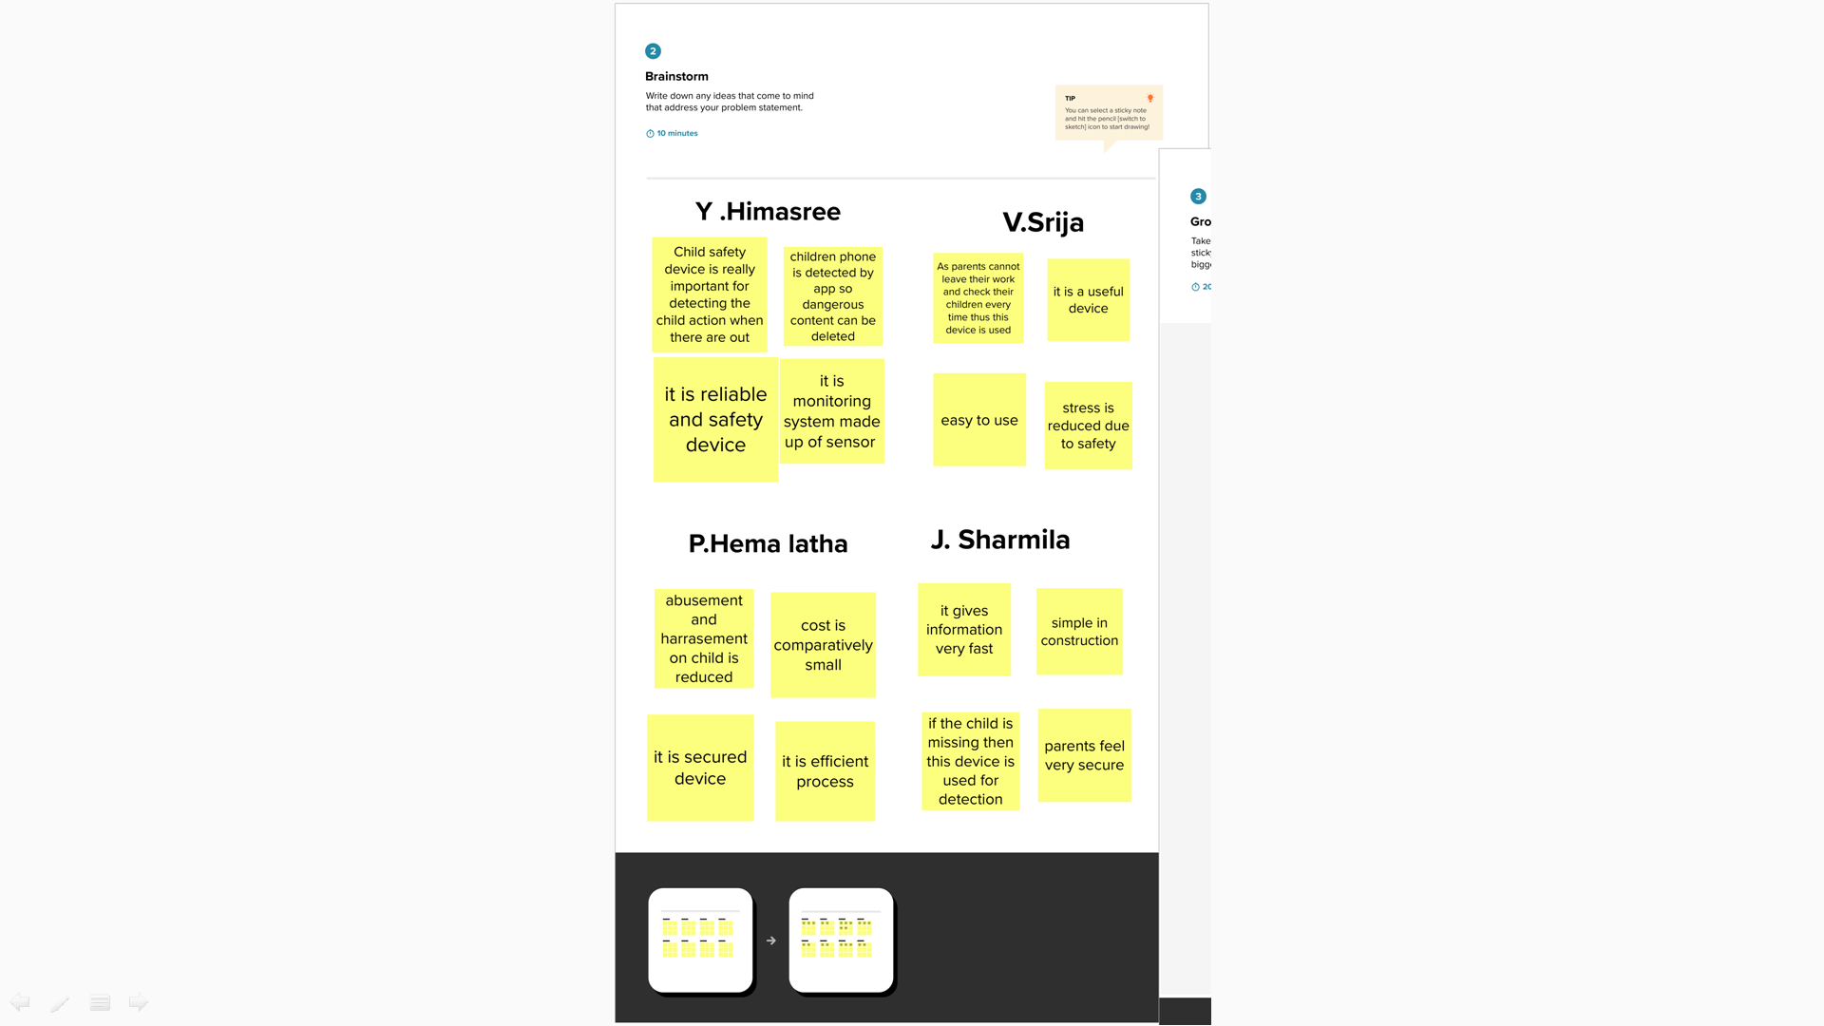

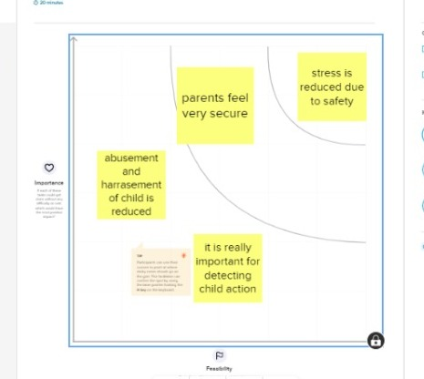

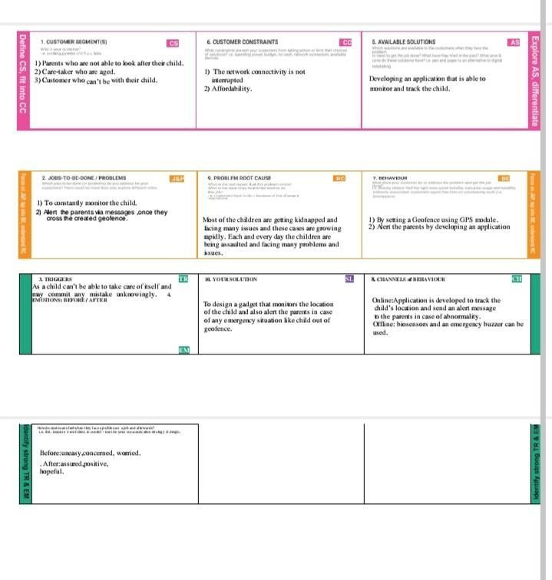

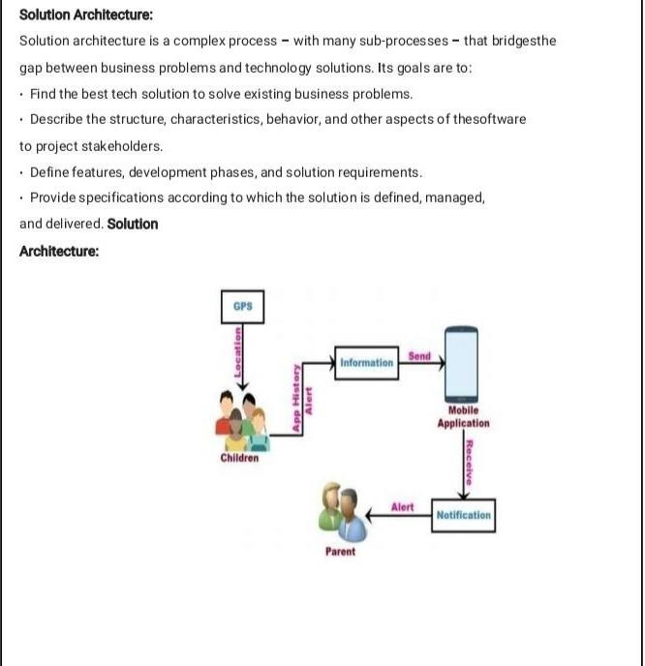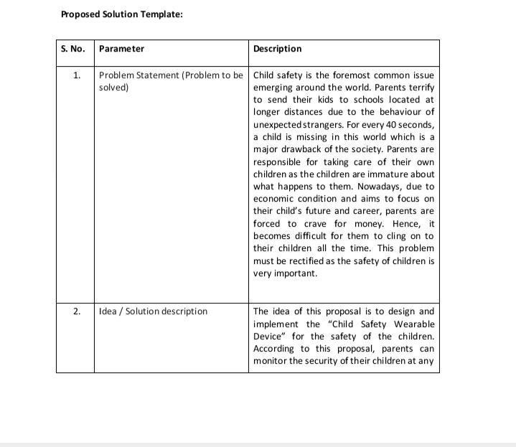

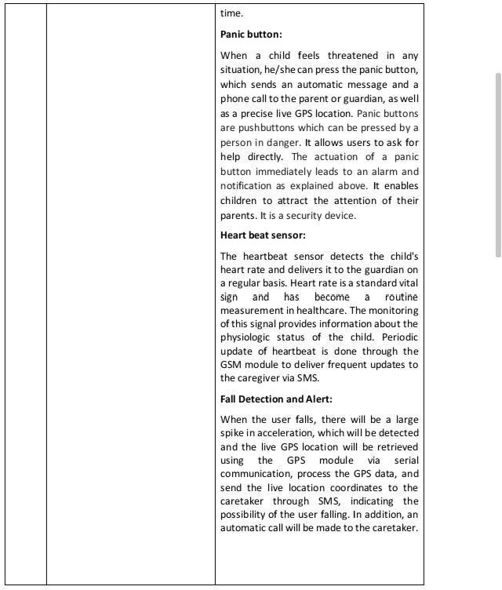

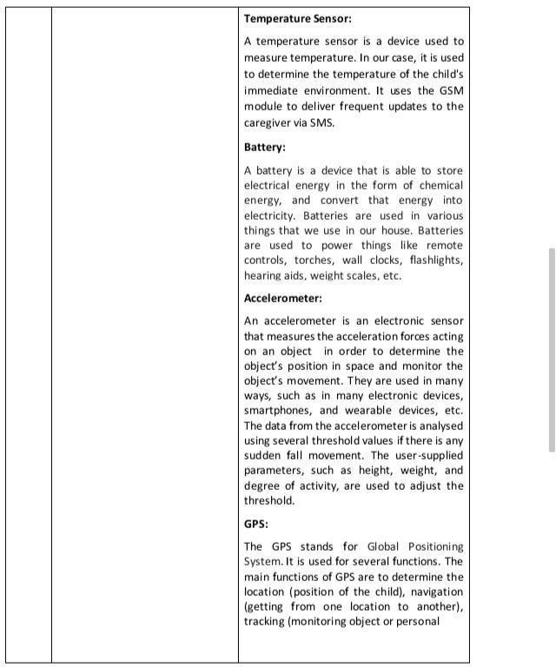

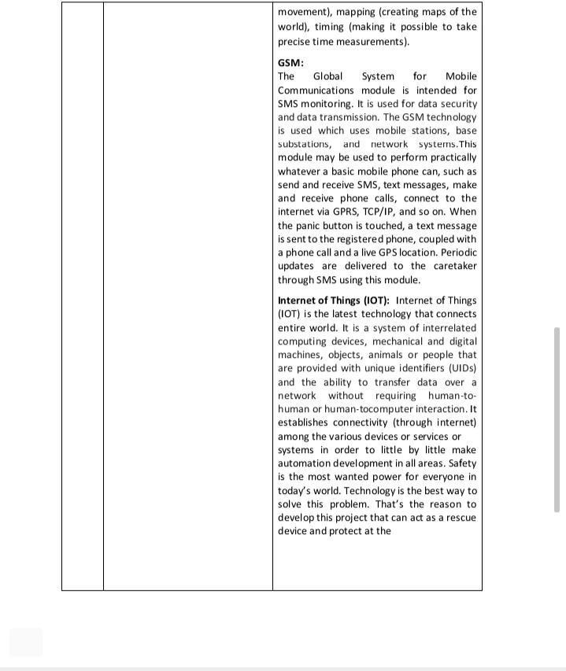

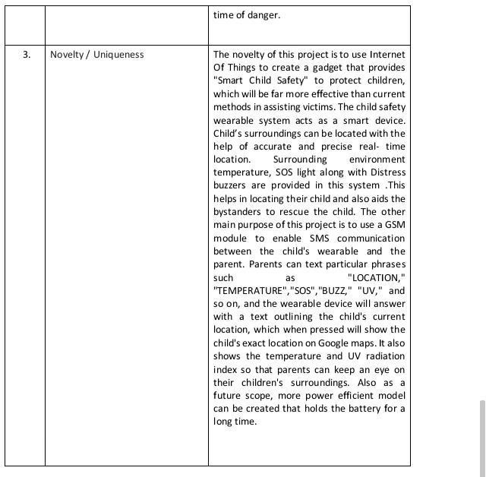

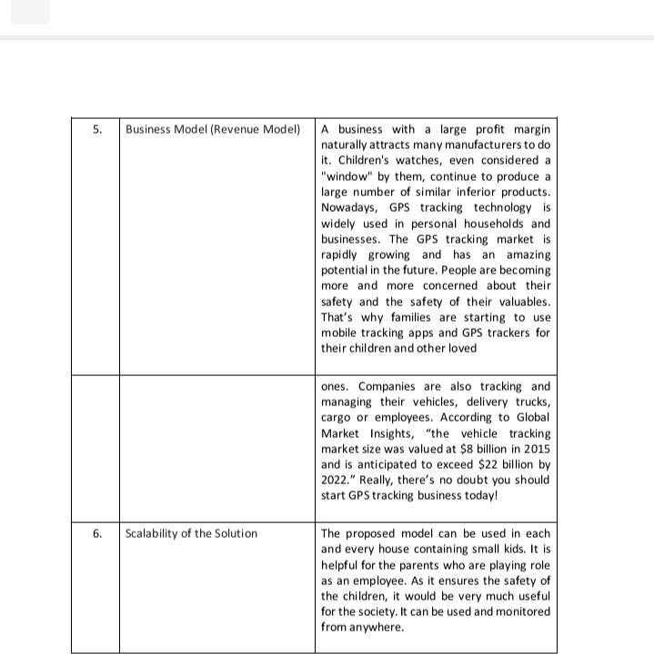

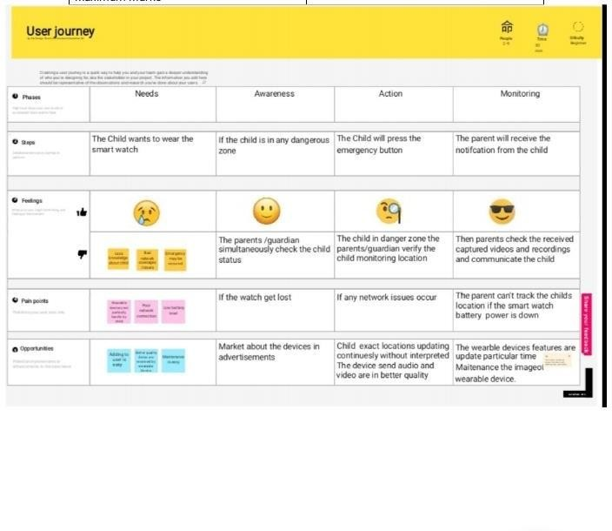

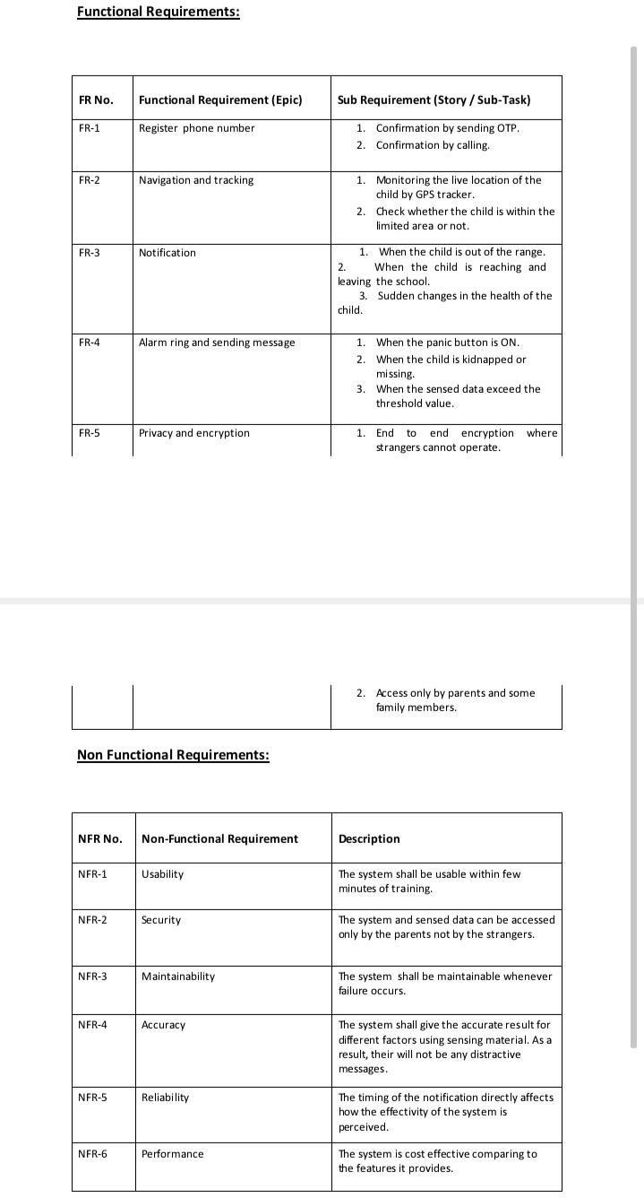

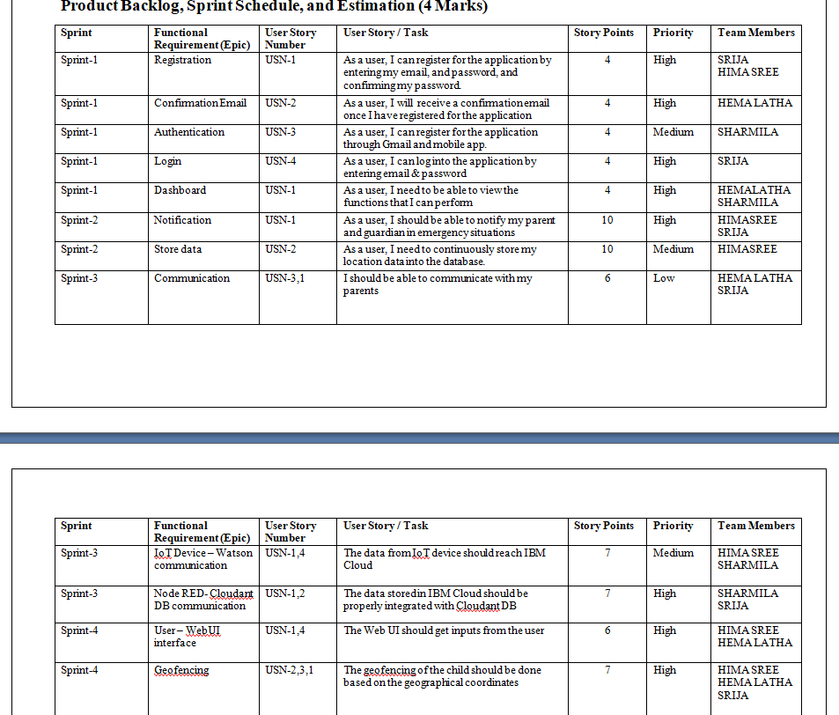

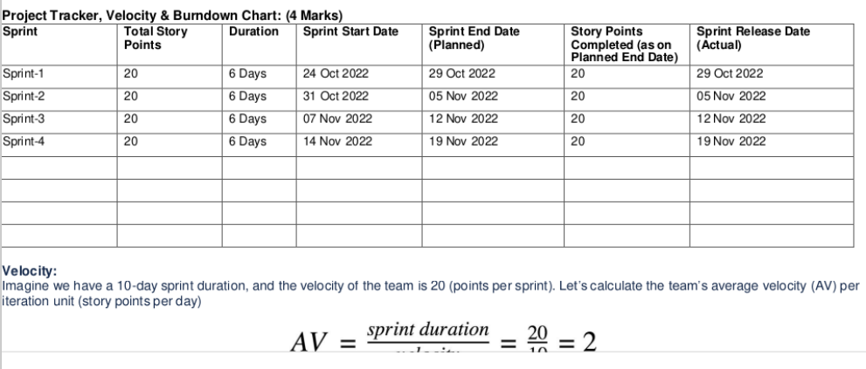

DATA FLOW DIAGRAM

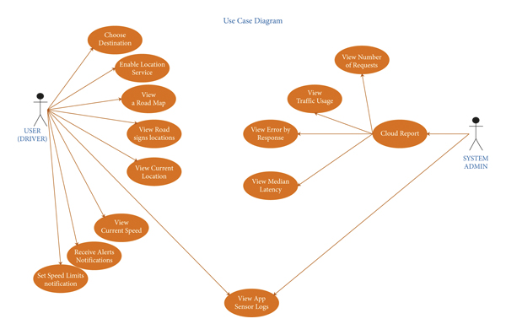

MILE STONE AND ACTIVITY LIST

## Prerequisites

*IBM Cloud Services

*Software

## 2.ProjectObjectives

*Creating Abstract

*Brainstorming

## 3.Create And Configure IBM CloudServices

*Creating IBM Watson IoT Platform And Device

*Creating Node- Red Service

*Creating Database InCloudant DB

## 4.IdeationPhase

*Creating a Literature SurveyOn The Selected Project & Information Gathering

*Preparing an Empathy Map

*Ideating

## 5.Project Design Phase-1

*Proposing a Solution

*Preparing a Solution Fit

## 6.Project Design Phase-2

*Creating a Customer Journey map

*Analyzing Functional Requirements

*Creating Data Flow Diagram

*Creating Technology Architecture

## 7.Project planningPhase

* Preparing Milestones & Activity List

*Creating Sprint Delivery Plan

## 8.Project DevelopmentPhase

## *Developing an IoT device using IBM Watson IOT python and node red services

## *Making sure all the requirements are met

## *Product is tested

## *Quality of the product is checked

## *The project is now ready for use

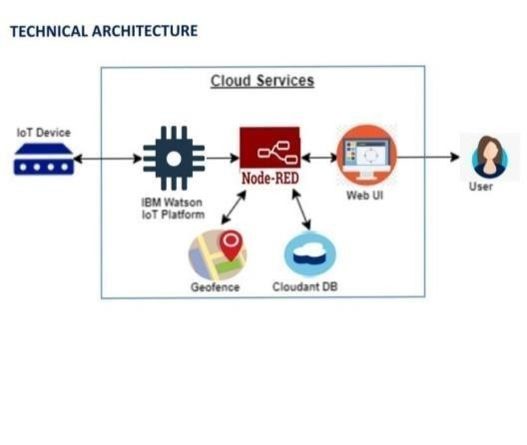

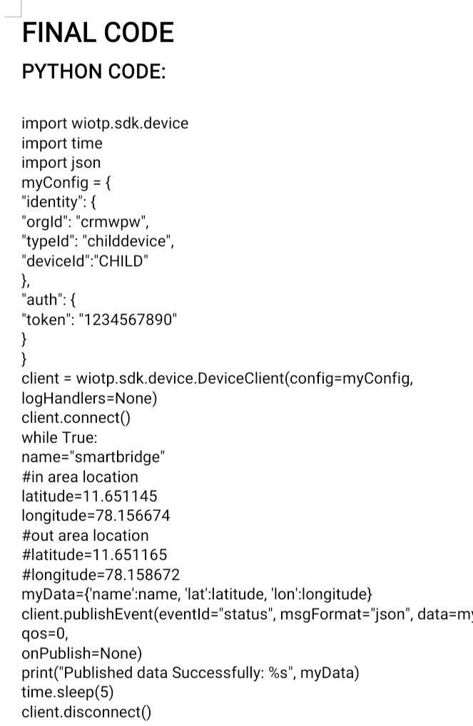

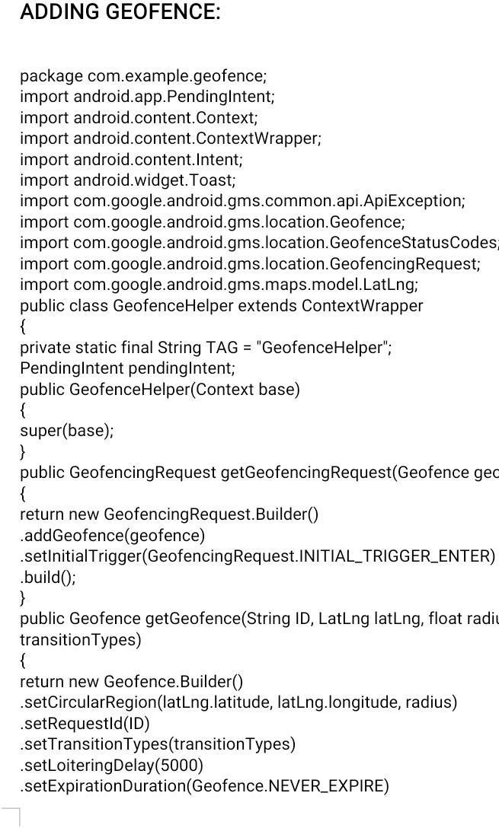

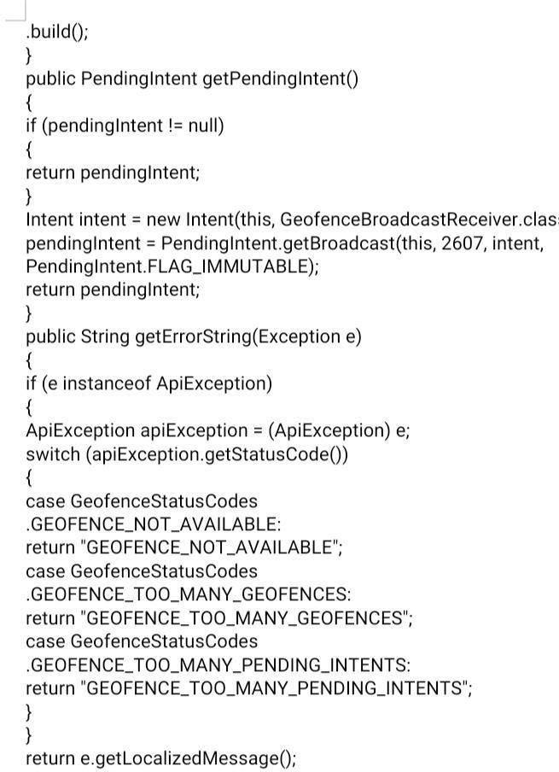

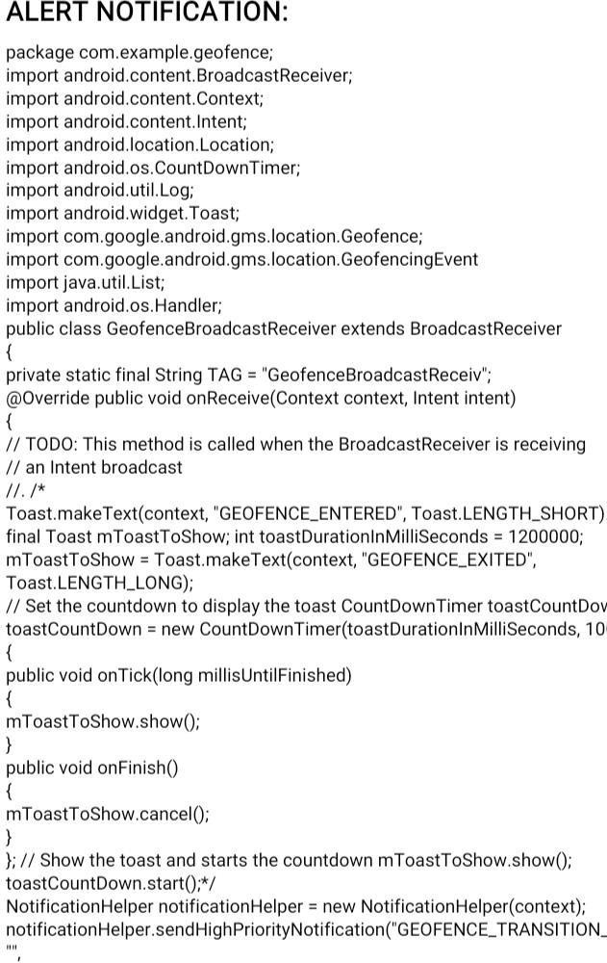

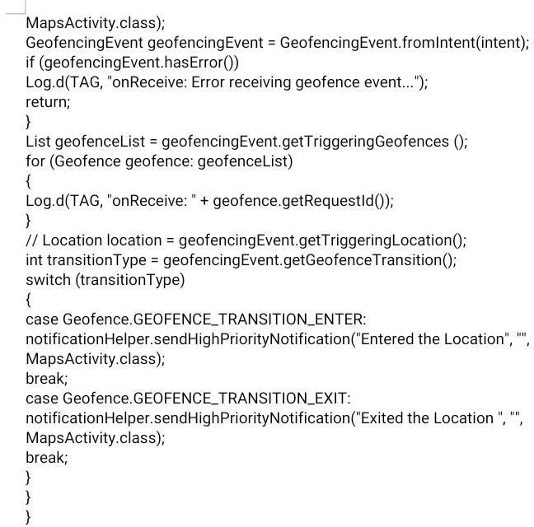

Result:

successfully completed.

FUTURESCOPE

This project is actually developed for parents to keep track The child where about. Nowadays, child is easier influenced by their Friends, and they might even get cheated or kidnapped by any of the Strangers. By developing this system can track child current location. The application will deal with the Android platform and is Utilized for GPS following between different mobile devices .The Application is mindful to keep track the location of the device. The parent Or child account can be edit by parents. The application will include the Route history trace where the parent track for the route their child Traversed during a certain period of time. The application in the device Will update the location of the child to the application by having the Interval time for 30 in, 1 hour and 2 hour. Parent can select the interval Time to view the current location of the child. Parent also can make call From the application if any inconvenience happens when the location not Found or track.